

**Savitribai Phule Pune University**

**T. Y. B. B. A. (C.A.) Semester - V**

**(CBCS 2019 Pattern)**

**PRaCTICAL SLIP**

**Name : Lalit devidas patil**

**College Name: SINHGAD COLLEGE OF ARTS & COMMERCE WARJE PUNE-58**

|  |  |  |  |  |
| --- | --- | --- | --- | --- |
|  |  |  |  |  |

**Roll no : 106 Division:b seat NO:**

**Academic year : 2024-25**

***Certificate***

**This is to certify that**

**Mr. PATIL LALIT DEVIDAS**

**Seat Number_____of T.Y.BBA(CA) Sem - V has Successfully completed Laboratory course**

**(PYTHON) in the Year . He has scored mark out of 10 (For Lab Book).**

**--------------------------------**

**Subject Teacher H.O.D./Coordinator**

**Internal Examiner External Examiner**

**Slip 1**

**A) Write a Python program to accept n numbers in list and remove duplicates from a list.**

def remove_duplicates(numbers):

return list(set(numbers))

n = int(input("Enter the number of elements: "))

numbers = []

for _ in range(n):

num = int(input("Enter a number: "))

numbers.append(num)

print("Original list:", numbers)

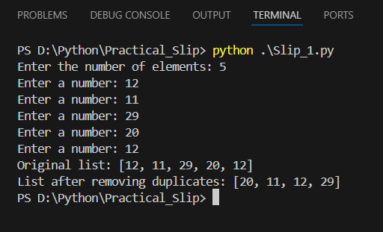print("List after removing duplicates:", remove_duplicates(numbers))

**B) Write Python GUI program to take accept your birthdate and output your age when a button is pressed.**

import tkinter as tk

from tkinter import messagebox

from datetime import datetime

def calculate_age():

try:

birth_date = datetime.strptime(entry.get(), "%Y-%m-%d")

today = datetime.today()

age = today.year - birth_date.year - ((today.month, today.day) < (birth_date.month, birth_date.day))

messagebox.showinfo("Age", f"Your age is: {age} years")

except ValueError:

messagebox.showerror("Invalid date", "Please enter a valid date in YYYY-MM-DD format")

app = tk.Tk()

app.title("Age Calculator")

label = tk.Label(app, text="Enter your birthdate (YYYY-MM-DD):")

label.pack(pady=10)

entry = tk.Entry(app)

entry.pack(pady=5)

button = tk.Button(app, text="Calculate Age", command=calculate_age)

button.pack(pady=20)

app.mainloop()

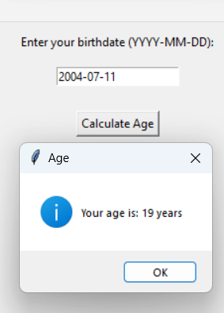

**Slip 2**

**A)** **Write a Python function that accepts a string and calculate the number of upper case letters and lower case letters.**

**Sample String: 'The quick Brown Fox'**

**Expected Output: No. of Upper case characters: 3**

**No. of Lower case characters: 13**

def count_upper_lower(s):

upper_case = sum(1 for char in s if char.isupper())

lower_case = sum(1 for char in s if char.islower())

return upper_case,lower_case

sample_string = 'Lalit Devidas Patil'

upper_count, lower_count = count_upper_lower(sample_string)

print(f"No. of Upper Case Characters: {upper_count}")

print(f"No. of Lower Case Characters: {lower_count}")

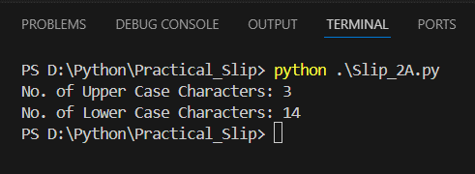

**B) Write Python GUI program to create a digital clock with Tkinter to display the time.**

import tkinter as tk

import time

class DigitalClock:

def __init__(self, root):

self.root = root

self.root.title("Digital Clock")

self.root.geometry("400x200")

self.clock_label = tk.Label(root, font=("times", 50, "bold"), bg="black", fg="white")

self.clock_label.pack(anchor='center')

self.update_clock()

def update_clock(self):

current_time = time.strftime("%H:%M:%S")

self.clock_label.config(text=current_time)

self.root.after(1000, self.update_clock)

if __name__ == "__main__":

root = tk.Tk()

clock = DigitalClock(root)

root.mainloop()

